THE FROWYK CHAPEL PROJECT, ST. GILES SOUTH MYMMS
WHY FINANCIAL ASSISTANCE IS NEEDED
Abstract
St. Giles South Mymms is facing costs of over £116,000 to repair and restore the Frowyk Chapel containing the tomb of Thomas Frowyk. The church is Grade 1 Listed, because of the beauty and importance of these structures. They have been badly affected by subsidence and structural movement, and currently the chapel is closed to visitors and for worship. So far £16,000 has been granted towards the cost of the project and the church can put some funds towards this. At least another £50,000 is needed so that the church can attend to other repairs.
The heritage significance of St. Giles and its Frowyk Chantry Chapel
There has been a church in South Mymms since around 1135. Around 1380 the tower was built, probably by Henry Frowyk (d.1386). His son, Thomas Frowyk (d.1449) rebuilt the nave in about 1425 and commissioned a chantry chapel to the north of the chancel. Three generations later Henry Frowyk (d.1527) built the north aisle (1526) and rebuilt the chantry chapel, including a magnificent canopied tomb for his son, Thomas, who predeceased him in 1523. The Frowyk family bought a country seat north of Barnet around 1270, being City merchants (Grocers, Goldsmiths and Mercers among other trades). Over the next three centuries they enlarged and beautified St. Giles church. The chantry chapel is a remarkable late Gothic/early Renaissance structure, and it is Thomas Frowyk’s tomb (as well as his father’s) which led to the church being Grade 1 Listed.
A further feature of the chapel is the wooden screen surrounding it on the south and west sides. There is an entrance through each side, with carvings of the Frowyk heraldic beast (a leopard) on one side and Green men on the other. It was moved eastwards towards the tomb when the Vestry was created, and back to the step up from the aisle in 1877. The East Window is by Ninian Comper (1939). It became effectively a Lady Chapel, and is used for smaller group services, and also for the Easter Vigil, as well as for meetings. The chapel and the Frowyk monuments are described in the latest edition of Pevsner’s Hertfordshire as the chief pride of the church.
The problem: subsidence and damage to the monumental Frowyk tomb
The tomb and its chapel have suffered badly in recent years from the effects of subsidence. The underlying geology is London clay over an underlying chalk seam. A line of lime trees has desiccated the clay over the last century, causing subsidence, and this has been exacerbated by water seeping through cracks and from a broken drain. The church has already paid, from its own resources, £23,625 for professional reports, investigations and repairs, so the drain is now repaired, and the lime trees have been removed.
The subsidence problem is long-standing: there is evidence that G.E. Street rebuilt the north wall of the church and strengthened it with buttresses. The west wall of the aisle also shows evidence of historical movement, and the north and east walls have a number of cracks, with the buttresses detaching from the wall; the stonework of the window lights has also moved, causing the leaded windows to distort. Mercifully the 1526 stained glass panels at the bottom of each light (aisle and chapel) appear not to be at risk yet. In 2016, following heavy rainfall, stonework along the north side of the church and chapel cracked, and the north wall and floor sank, causing the wooden chantry screen to distort, with its members beginning to spring apart. This has been stabilised, but will need to be levelled and reset. A long term solution may well have to be to underpin the north side of the church, which we are advised is likely to cost over £0.5m.
After the floor sank in 2016, and its surface became unsafe, the chapel was declared out of bounds, and is no longer open to the public. St. Giles receives many visitors each year, who come specifically to view the chapel and the tombs (guided by Pevsner and Simon Jenkins 1,000 Best Churches).
The project: Phases 1 and 2
Our Surveyors, Barker Associates Ltd., have engaged Ed Morton of The Morton Partnership to provide advice on the structure; the Skillington Workshop (Dr. David Carrington) to advise on conservation and repairs to the tomb; Hugh Harrison to advise on the screen; and Heritage Archaeology to attend during floor excavations to be carried out by the church’s usual builders, Lodge and Sons of Dunmow. Ed Morton was responsible for earlier advice, leading to the removal of the causes of subsidence, which has been largely successful, for the time being.
In January 2019 the DAC met with our Surveyors and Ed Morton, and agreed a two phase programme to repair and restore the interior of the chapel, since it is architecturally and historically significant. Phase 1 is in progress, and involves a GPR survey of the floor and trial holes to identify hollow areas. Meanwhile the canopy of the tomb is to be removed to prevent further damage to that structure. It is hoped that this will be completed by mid-October 2019.
Phase 2 involves dismantling the rest of the tomb, removing the ledger stones and pammets on the chapel floor, together with a small altar and its base, filling in the hollow areas of the floor and compacting them, before levelling and relaying the floor, and rebuilding the tomb on a concrete raft. At the same time, the west side of the wooden screen will have to be supported and then eased back into its original shape and position. This will enable the chapel to be re-opened to the public, and returned to the congregation and local community for normal use.
Other necessary works to St. Giles Church
Quinquennial Inspections have identified other works to be addressed, including repairs to the stonework on all external doors and windows; repairs to the porch and stonework on the south side of the church; repairs to the porch, with a possible project to install external glazed doors to prevent heat loss, and improve accessibility to the church. A rough estimate of these costs is £50,000.
Timescale
As noted above, Phase 1 is already under way. By early October the details of Phase 2 can be specified so that the church can petition for a Faculty for it. Works may commence as early as December 2019, and in any event should be complete by May 2020. While the works are being carried out, the chancel will be out of use (being used to store the component parts of the tomb)..
Costs and the need for support
As noted above, the church has already spent around £25,000 on preliminary works. Phase 1 costs are estimated to be £14,500, including fees and VAT. Phase 2 is estimated at this stage to cost £118,260, including fees and VAT. The costs of Phases 1 and 2 together amount to over £132,760 including fees and VAT. If we can reclaim most of the VAT, this reduces our eventual costs to about £116,000. St. Giles is fortunate to be well-endowed and supported by a specific Trust Fund. However our current expendable resources (as opposed to long-term investments) amount to about £122,000. So far grants have been made to the church by the Beds & Herts Historic Churches Trust, The Frances Coales Foundation and Allchurches Trust amounting to £16,000. If the church had only its available resources to spend on this Project, it would have £22,000 left to cover the £50,000 programme of other works noted above, normal maintenance of the church and any contingencies arising.
Consequently the church is seeking grants to meet both the outstanding costs of the Project and to replace its existing resources spent on the Project. A target of at least £50,000 is envisaged. A programme of appeals to the local community is planned in the early Autumn, and further approaches are being made to various funding bodies and charitable foundations. The funds thus raised will enable the church to continue to operate as a place of Christian worship into the long term future, and as a place of historical and architectural interest in the Diocese and the nation.
William Marsterson and Mark Edwards, Churchwardens

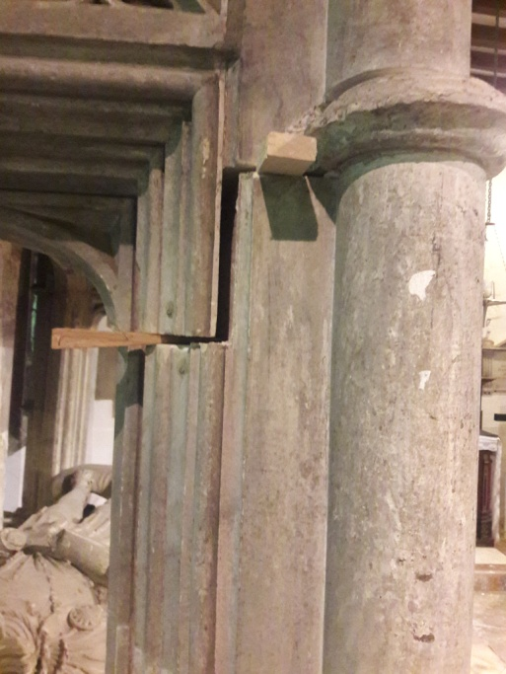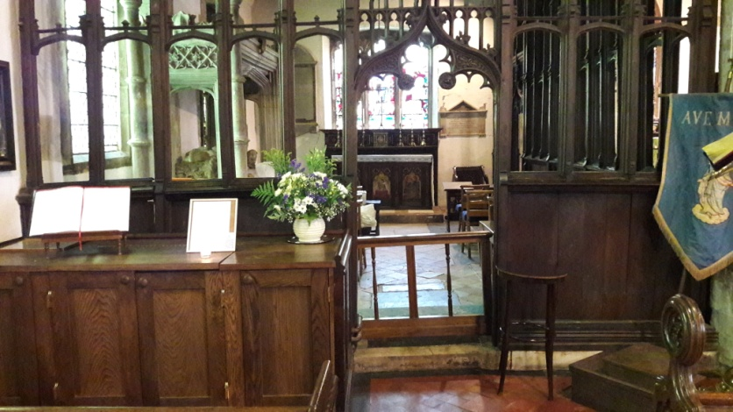
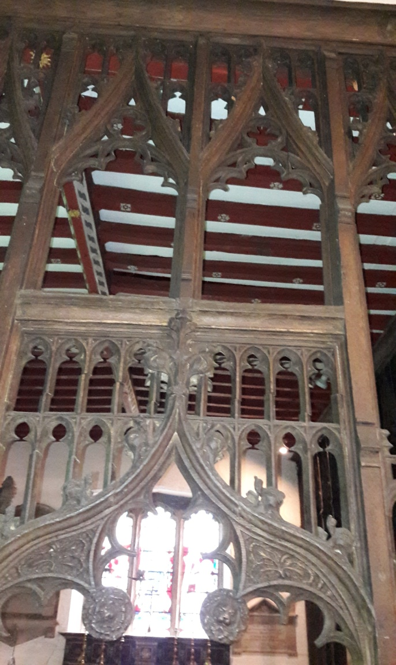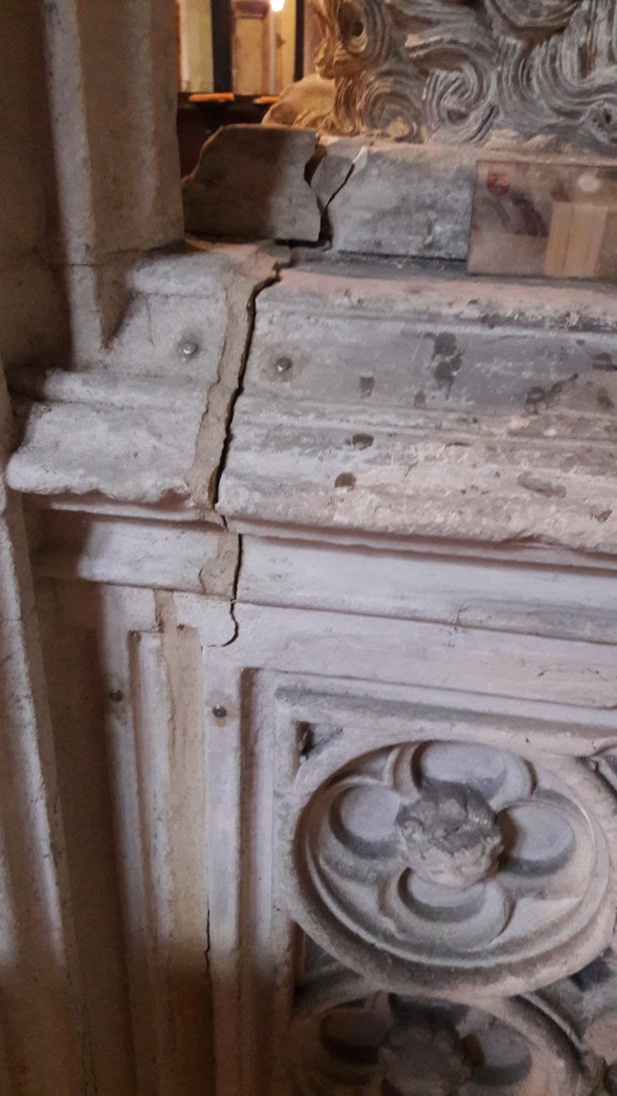
Top left: Thomas Frowk’s tomb, south-west pillar movment
Top right: Frowyk chantry and screen, showing distortion and left hand end sagging down
Bottom left: Screen showing stress. Bottom right: east end of Thomas Frowyk’s tomb.

